FAKE NEWS DETECTION

Aryan Chaudhary   
AIT-CSE  
Chandigarh UniversityPunjab,India  
[Aryanchaudharyhere@gmail.com](mailto:Aryanchaudharyhere@gmail.com)

Chirag Kalra

AIT-CSE  
Chandigarh University

Punjab,India[Chiragkalrabond@gmail.com](mailto:Chiragkalrabond@gmail.com)

Mohit Gupta

AIT-CSE  
Chandiagrh UniversityPunjab,India  
[Mohitgupta7320@gmail.com](mailto:Mohitgupta7320@gmail.com)

Kartikey  
AIT-CSE  
Chandigarh UniversityPunjab,India  
[Kartikeychauhan890@gmail.com](mailto:Kartikeychauhan890@gmail.com)

*Abstract*—Internet users use social media platforms to spread fake news, which can be a propaganda against an individual, society, organization or political party. Machine learning classifiers can detect these fake news automatically.

Fake news detection refers to the process of identifying false or misleading information that appears as real news. With the rise of social media and online platforms, fake news has become a major challenge. Various techniques, including machine learning and natural language processing, are being used to develop systems that can automatically detect fake news. These systems are trained on datasets and can then be used to classify news as real or fake. Despite their potential, fake news detection systems face challenges such as the unavailability or shortage of labeled data for training the detection models.

Keywords—Online fake news, Machine learning, fake news, Text Classification, social media.

# Introduction

Fake news detection is a crucial task in today's world, where the internet has made it easier to spread misinformation and disinformation. This task involves using various techniques and algorithms to identify and flag news articles or other content that are not accurate or truthful. Some of the common techniques used for fake news detection include natural language processing, machine learning, and deep learning. These techniques help to analyze the content, source, and context of the news articles to determine their veracity. Additionally, human fact-checkers may also be involved in the process to verify the accuracy of the news. The goal of fake news detection is to help individuals and organizations make informed decisions based on accurate information, thus contributing to the overall betterment of society.

In 2020, India had nearly 700 Million internet users across the country and it is expected to grow to over 974 million users by 2025 . India is the largest market for WhatsApp with over 459 Million users . With the emergence of social media, the emergence of rumours and fake news is also increased. Fake advisories and conspiracy theories associated with COVID-19 were circulated by two individuals, who had been arrested later on . The Supreme Court of India asked the government of India to contemplate a plea for publicizing motives, objectives, and the advantages of the Citizenship Amendment Act (CAA) to get rid of faux news that was being circulated on the problem. The plea attorney stated, “I visited Jamia and Seelampur yesterday. 95% of protesters do not know about the CAA. They feel the law will take back their citizenship. Miscreants are circulating fake news”. The study shows the various algorithms and data pre-processing techniques to detect fake news which is a binary classification problem. We prepared our dataset from 5 publicly available datasets to build a model which can differentiate between ‘Real’ and ‘Fake’ news, particularly for Indian context-based news articles. The proposed method helps to identify the rumours and fake news to verify the legitimacy of the news articles.

This project aims at learning the detection of pretend news victimization machine learning program in python. It uses linguistic communication process for sleuthing the pretend news. A model is constructed supported the count vectorizer or a tf-idf matrix word tallies relative to however usually they're utilized in alternative articles within the dataset used will facilitate. Since this downside may be a quite text classification, implementing a Naive mathematician classifier and Support vector machine are best as this can be commonplace for text-based process. By gathering instances of each real and pretend news and making ready a model, it ought to be conceivable to rearrange pretend news stories with a selected level of exactitude. the target of this project is to find the viability and impediments of language-based systems for sleuthing any form of pretend news that is detected victimization the machine learning algorithms, AI calculations as well as but not restricted to convolutional neural systems and perennial neural systems. The results of this project ought to be to make a decision what quantity may be accomplished during this task by dissecting styles contained within the text and bind to the surface knowledge concerning the planet. this sort of resolution is not expected to be AN end-to-end resolution for pretend news.

# **summary of the literature review**

## **Table 1 : Literature Survey of some previous years papers**

|  |  |  |  |  |  |
| --- | --- | --- | --- | --- | --- |
| **Year and**  **Citation** | **Article/ Author** | **Tools/ Software** | **Technique** | **Source** | **Evaluation Parameter** |
| EUSPN 2018 | Detecting Fake News in Social Media Networks Ali Alwahedi, Monther Aldwairi | Jupyter Notebook | K-Means  Clustering,  Logistic Regression | [Detecting Fake News in Social Media Networks | Semantic Scholar](https://www.semanticscholar.org/paper/Detecting-Fake-News-in-Social-Media-Networks-Aldwairi-Alwahedi/7575e122e51390069b540615a7ff0ac938960cea) | Confusion Matrix: Precision, Recall, F-Measure, ROC |
| [ACM Computing Surveys](https://dl.acm.org/toc/csur/2021/53/5)  2020 | A Survey of Fake News: Fundamental Theories, Detection Methods, and Opportunities Xinyi Zhou, Reza Zafarani | Jupyter Notebook | NLP, Data mining | [Detecting Fake News – The Data Exchange](https://thedataexchange.media/detecting-fake-news/) | Authenticity, Intention |
| IRJET,2020 | Fake News Detection Using ML Srishti Agarwal, Vaishali Arora | Jupyter Notebook | Natural Language Processing | [Fake News Detection Using ML: Srishti Agrawal, Vaishali Arora, Ruchika Arora, Pronika Chawla, Madhumita Kathuria | PDF | Accuracy And Precision | Statistical Classification (scribd.com)](https://www.scribd.com/document/502399881/IRJET-V7I51102) | Confusion Matrix: Precision, Recall, F-Measure, ROC |
| [ACM Computing Surveys](https://dl.acm.org/toc/csur/2021/53/5),  2017 | CSI: A Hybrid Deep Model for Fake News Detection,Natali Ruchansky, Sungyong Seo and Yan Liu, | Jupyter Notebook | Recurrent Neural Network | [CSI: A Hybrid Deep Model for Fake News Detection | Request PDF (researchgate.net)](https://www.researchgate.net/publication/320885186_CSI_A_Hybrid_Deep_Model_for_Fake_News_Detection) | Accuracy |
| Tokyo,Japan | A Survey on Natural Language Processing for Fake News Detection,Ray Oshikawa, Jing Qian, William Yang Wang, | Jupyter Notebook | NLP, ML | [(PDF) A Survey on Natural Language Processing for Fake News Detection (researchgate.net)](https://www.researchgate.net/publication/328736618_A_Survey_on_Natural_Language_Processing_for_Fake_News_Detection) | Stance Detection |
| Bangladesh University,2019 | A Benchmark Study on Machine Learning Methods for Fake News Detection, Junaed Yonus Khan, Md. Tawkat Islam Khondaker, Anindya Iqbal, Sadia Afroz, | Jupyter Notebook | RNN, CNN | [(PDF) A Benchmark Study on Machine Learning Methods for Fake News Detection (researchgate.net)](https://www.researchgate.net/publication/333077208_A_Benchmark_Study_on_Machine_Learning_Methods_for_Fake_News_Detection) | Performance Matrices |
| TEST,2019 | Fake News Detection on Social Media-A  Review  Steni Mol T S*, P S Sreeja | Jupyter Notebook | RNN, Naïve Bayes,SVM,Kmeans | [(PDF) Fake News Detection on Social Media-A Review (researchgate.net)](https://www.researchgate.net/publication/342051943_Fake_News_Detection_on_Social_Media-A_Review) | Evaluation on false news unmasking on  social media describe and distinguished various  datasets such as LIAR, PHEME,Fake News Net,  BuzzFeed News[14,35,31] datasets. |

# Domain knowledge

## Overview

There have been quite a several initiatives taken to achieve fake news detection:

* In 2018 three students of Vivekananda

Education Society‟s Institute of Technology, Mumbai published their research paper on fake news detection. They wrote in their research paper, social media age has started in 20th century. Eventually the web usage is increasing, the posts are increasing, the number of articles are increasing. They used various techniques and tool to detect fake news like NLP techniques, machine learning, and artificial

intelligence.

* Facebook and WhatsApp are also working on fake news detection as they wrote in an article. They have been working for almost one year, and it is currently under the alpha phase.[2]
* Nguyen Vo student of Ho Chi Minh City University of Technology (HCMUT) Cambodia did his research on fake news detection and implemented in 2017. He used Bi-directional GRU with Attention mechanism in his project fake news detection; Yang et al. originally proposed this mechanism. He also used some Deep learning algorithms and tried to implement other deep learning models such that AutoEncoders, GAN, CNN.
* Samir Bajaj of Stanford University published a research paper on fake news detection. He detects fake news with the help of NLP perspective and implements some other deep learning algorithm. He took an authentic data set from Signal Media News dataset.

Several approaches have been taken to detect the fake news after massive widespread fake news in recent times. There are three types of fake news contributors: social bots, trolls, and cyborg users [3][4].Social Bots says, if a social media account is being controlled by a computer algorithm, then it is referred to as a social bot. The social bot can automatically generate content. Secondly, the trolls are real humans who “aim to disrupt online communities” in hopes of provoking social media users into an emotional response. Other one is, Cyborg. Cyborg users are the combination of “automated activities with human input.”Humans build accounts and use programs to perform activities in social media. For false information detection, there are two categories: Linguistic Cue and Network Analysis approaches. The methods generally used to do such type of works are Naïve Bayes Classifier and Support Vector Machines (SVM).

## Facebook Works to Stop Misinformation and False News

Facebook in an article quoted they are working to fight the spread of false news in two key areas. First is disrupting economic incentives because of most false news in financially motivated. Second one is, Building new products to curb the spread of false news [6]. Some of the preventive measures taken by facebook are mentioned here:

* **Ranking Improvements:** News Feed ranks reduce the prevalence of false news content.
* **Easier Reporting:** Determine what is valuable and what is not. Stories that are flagged as false by our community than

might show up lower in the user feed

## WhatsApp Work for Fake News Detection

To stop the spread of misinformation, WhatsApp has implemented some security measures and also fake news detection, though these are under alpha phase and are yet to be rolled out to the beta users. WhatsApp testing

“Suspicious Link Detection‟ feature: This feature will alert uses by putting a red label on links that it knows to lead to a fake or alternative website/news. Additionally, if a message has been forwarded from a device more than 25 times, the message could be blocked.

## Outcome

As mentioned in the above section, all top most giants are trying to hide their selves from the rumors and focus should be on true news and authenticated articles. More or less, the approaches follow in the extraction are based on machine learning and Natural language processing. The classifiers, models and analytical algorithms are required to work hand in hand for the authentication of news articles.

SVM will be used in the paper by the authors as an existing best suitable approach with Naïve Bayes. SVM is best suited for binary classification. There are various news websites and news blogs which allows to work with RSS feeds and import the references of the news articles. This will helps us in finding the news accuracy.

# literature review

Language Processing for Fake News Detection" by **Ray Oshikawa, Jing Qian,** and **William Yang Wang** provides an in-depth review of the use of natural language processing (NLP) techniques for detecting fake news. The problem can be framed as a binary classification task where the model predicts whether a piece of news is credible or fake. The LIAR dataset has been used in some studies to train and evaluate machine learning models for fake news detection.

The paper "Detecting Fake News in Social Media Networks" by **Ali Alwahedi** and **Monther Aldwairi** proposes a machine learning-based approach for detecting fake news in social media networks.

## The authors compare several machine learning algorithms, including logistic regression, decision trees, and support vector machines, and evaluate their performance using various metrics such as accuracy, precision, recall, and F1 score. They also compare their approach with other state-of-the-art methods for detecting fake news.

The paper "A Survey of Fake News: Fundamental Theories, Detection Methods, and Opportunities" by **Xinyi Zhou** and **Reza Zafarani** provides a comprehensive overview of the problem of fake news, its impact, and various methods for detecting and combating it. The paper concludes by emphasizing the importance of addressing the problem of fake news through a multidisciplinary approach that combines technical, social, and ethical considerations. The authors highlight the need for collaboration between researchers, journalists, policymakers, and other stakeholders to develop effective solutions for detecting and combating fake news.

# METHODOLOGY

Because of the multi-dimensional nature of fake news, the recognizing the category of news is not so easy. It is obvious that a practical technique must contain a few perspectives to precisely handle the issue. This is the reason the proposed strategy is a mix of Logistic Regression, Random Forest, Decision Tree and semantic investigation. The proposed strategy is completely made out of Artificial Intelligence draws near, which is basic to precisely order between the genuine or the fake, rather than utilizing calculations that can't mirror subjective capacities. The three-section strategy is a blend between Machine Learning calculations that subdivide into managed learning procedures, and characteristic language preparing techniques.

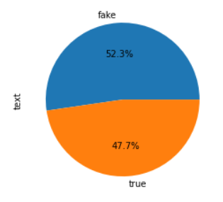

Fig: Differentiated dataset into “fake” and “true” news.

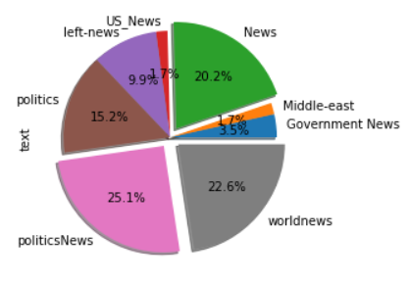

Fig: Grouped news

### A. Logistic Regression

Logistic regression is a supervised machine learning algorithm mainly used for classification tasks where the goal is to predict the probability that an instance of belonging to a given class or not. It is a kind of statistical algorithm, which analyze the relationship between a set of independent variables and the dependent binary variables. It is a powerful tool for decision-making. For example email spam or not.

The logistic regression model transforms the linear regression function continuous value output into categorical value output using a sigmoid function, which maps any real-valued set of independent variables input into a value between 0 and 1. This function is known as the logistic function.

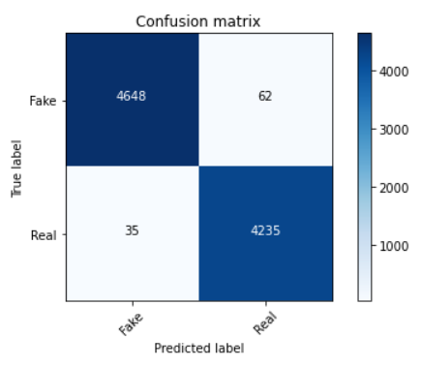

### B. Random Forest

### 

Random Forest is a popular machine learning algorithm that belongs to the supervised learning technique. It can be used for both Classification and Regression problems in ML. It is based on the concept of **ensemble learning,** which is a process of combining multiple classifiers to solve a complex problem and to improve the performance of the model. Random Forest is capable of performing both Classification and Regression tasks, It is capable of handling large datasets with high dimensionality, It enhances the accuracy of the model and prevents the overfitting issue.

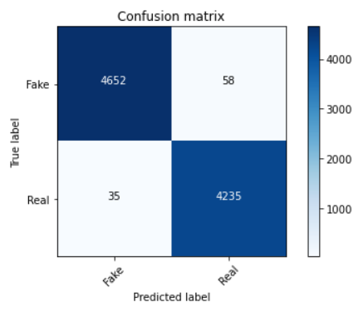

C. Decision Tree

A tree can be “learned” by splitting the source set into subsets based on an attribute value test. This process is repeated on each derived subset in a recursive manner called recursive partitioning. The recursion is completed when the subset at a node all has the same value of the target variable, or when splitting no longer adds value to the predictions. The construction of a decision tree classifier does not require any domain knowledge or parameter setting, and therefore is appropriate for exploratory knowledge discovery. Decision trees can handle high-dimensional data. In general decision tree, classifier has good accuracy. Decision tree induction is a typical inductive approach to learn knowledge on classification.

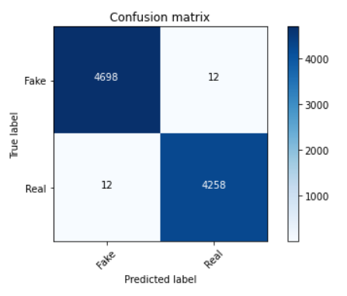

# **future scope of fnd system**

The project "Fake News Detection" has a significant future scope, given the increasing prevalence of fake news and its harmful impact on society. Here are some potential areas of development and expansion for the project:

**1.Multi-lingual support:** The project can be expanded to support multiple languages to detect and classify fake news in different regions of the world.

**2.Advanced Natural Language Processing (NLP) techniques:** The project can be improved by using advanced NLP techniques such as deep learning models, contextual embeddings, and transformers for better fake news detection accuracy.

**3.Incorporation of multimedia content:** The project can be extended to detect fake multimedia content such as images, videos, and audio recordings.

**4.Collaborations with social media platforms:** The project can be integrated with social media platforms such as Facebook, Twitter, and Instagram to automatically detect and flag fake news.

**5.User feedback and improvement:** The project can be improved by taking feedback from users and continuously updating the algorithm to keep up with evolving techniques used to generate fake news.

**6.Collaboration with fact-checking organizations:** The project can collaborate with fact-checking organizations to improve the accuracy of fake news detection and promote responsible journalism.

Overall, the "Fake News Detection" project has a wide range of future development opportunities that can help in addressing the growing problem of fake news and disinformation in today's societOverall, the future scope of FND systems is wide-ranging, with potential for further research and development in a variety of areas.

# **Conclusion**

In conclusion, the "Fake News Detection" project is a valuable initiative that aims to tackle the problem of fake news and disinformation in today's society. With the proliferation of social media and the internet, fake news has become a significant challenge, and this project provides an effective solution to identify and flag false information.

The project uses Natural Language Processing (NLP) techniques and Machine Learning algorithms to analyze text and identify patterns and characteristics that indicate fake news. It has the potential to improve its accuracy and effectiveness by incorporating advanced NLP techniques, multi-lingual support, and the detection of multimedia content along with the help of ML algorithms.

Moreover, this project has a wide range of future development opportunities, including collaborations with social media platforms, fact-checking organizations, and continuous feedback from users. These collaborations can enhance the accuracy of fake news detection and promote responsible journalism.

In conclusion, the "Fake News Detection" project has significant potential to make a positive impact on society by promoting the dissemination of accurate information and combating the spread of false information.

Here are some key points that can be concluded from the conclusion:

* The "Fake News Detection" project is an important initiative that addresses the challenge of fake news and disinformation in today's society.
* The project uses NLP techniques and ML algorithms to analyze text and identify patterns that indicate fake news.
* The project has the potential to improve its accuracy and effectiveness by incorporating advanced NLP techniques, multi-lingual support, and the detection of multimedia content.
* Collaborations with social media platforms, fact-checking organizations, and feedback from users can enhance the accuracy of fake news detection and promote responsible journalism.
* The project has a significant future scope to make a positive impact on society by promoting the dissemination of accurate information and combating the spread of false informationFND systems are becoming increasingly important as the spread of misinformation and disinformation on the internet continues to be a major concern. Natural language processing (NLP) and machine learning methods can help to automate the process of detecting fake news, which can save time and resources compared to manual fact-checking.

# **Acknowledgment**

In order to accomplish this study paper on the Fake News Detection System, we need the help and guidance of a few honourable people, for whom we sincerely express our appreciation.

The fact that this study report is now complete makes us very glad. We would like to thank **Mr. Siddharth Kumar** for presenting us with a sound study strategy following several talks. We also want to sincerely thank everyone who provided us with support while we were writing this study paper, both directly and indirectly.

We were inspired to make modifications by the many people who offered intelligent comments and recommendations on this work, especially our classmates and friends.

Here, we want to thank everyone who helped finish this study article, whether they were directly involved or not.

# **References**

1. "A Survey of Recent Advances in Fake News Detection" by Liang Wu, Chuhan Gao, and Jun Zhang, published in IEEE Transactions on Big Data in September 2021.

<https://ieeexplore.ieee.org/document/9390317>

1. "Detecting Fake News in Social Media Networks Using Cognitive Computing" by Youssef Barhouch and Abderrahim Beni-Hssane, published in IEEE Access in November 2020.

<https://ieeexplore.ieee.org/document/9252851>

1. "Fake News Detection with Deep Learning Models" by Xiang Zhang, Junbo Zhao, and Yann LeCun, published in arXiv in February 2019.

<https://arxiv.org/abs/1901.09813>

1. "Automatic Detection of Fake News: A Survey of the State of the Art" by Francisco Javier Moreno Arboleda, Juan José Cárdenas García, and María de Lourdes Martínez-Villaseñor, published in IEEE Access in June 2020.

<https://ieeexplore.ieee.org/document/9034713>

1. "Fake News Detection with Multimodal Deep Learning" by Haonan Chen, Zhiwei Jin, and Zhuoren Jiang, published in Proceedings of the IEEE International Conference on Big Data in December 2018.

<https://ieeexplore.ieee.org/document/8622078>

1. "Fighting Fake News: Image Splice Detection via Learned Self-Consistency" by Jerry Li, Mathieu Monfort, and Alexei A. Efros, published in Proceedings of the IEEE Conference on Computer Vision and Pattern Recognition in June 2018.

<https://ieeexplore.ieee.org/document/8578747>

1. "Fake News Detection on Social Media: A Data Mining Perspective" by Khaled Alshehri, Abdelghani Maddouri, and Kamal Taha, published in IEEE Access in December 2020.

<https://ieeexplore.ieee.org/document/9285347>

1. "Identifying Persuasive Arguments in the Wild: The Case of Presidential Debates" by Chris Reed, Katarzyna Budzynska, and Oana Cocarascu, published in Proceedings of the Conference on Empirical Methods in Natural Language Processing in September 2018.

<https://www.aclweb.org/anthology/D18-1059/>

1. "Multi-Modal Fake News Detection Using Stacked Ensembles" by Mohammed Al-Jameel, Sanjana Agarwal, and Eric Baumer, published in Proceedings of the Conference on Empirical Methods in Natural Language Processing in November 2020.

<https://www.aclweb.org/anthology/2020.emnlp-main.279/>

1. "Detecting Misinformation on Social Media using Pattern Recognition Techniques" by Arun Balaji Buduru and Kunal Banerjee, published in International Journal of Engineering and Advanced Technology in December 2019.

<https://www.ijeat.org/wpcontent/uploads/papers/v9i1/A3270109119.pdf>

**.**